# **Intention Estimation & Cognitive Emulation for Deceptive Military Decision Making**

# **Semester Research Project Report**

# **By**

Avnish Kumar

Divyanshu Shrivastava

Himanshu Saini

Nitin Agrawal

Prashant Sinha

Raghavendra Tripathi

Shivam Sharma

# **Under the guidance of**

# **Dr. A.K. Sinha, Scientist ‘G’**

# ciclogo.pnglogo.png

# **Defence Terrain and Research Laboratory**

# **Defence Research and Development Organization**

# **Ministry of Defence**

# **January 2016**

# **Index**

**Abstract**

**Chapter 1: Introduction**

**Chapter 2: Intention Model**

2.1 Process Flow of Intention Model-Introduction

2.2 Gross Intention Estimator (FN-BDI)

2.3 Emulator (RNNPB)

2.4 Error Teaching (Kalman Filter)

2.5 Corrector (ANFIS)

**Chapter 3 : Deception Model Scenario Simulation Using Unreal Engine**

3.1 Unreal Engine

3.2 Scenario Entities

3.3 Scenario Model View

**Chapter 4 : Game theoretic analysis and belief based intention estimation**

**Abstract**

Military decision making is a complex process especially in pursuit evasion scenario wherein autonomous agents are artificially equipped with intelligence. The situation further is typical when deception is employed. The current study aims at evolving models for decision making scenarios such as habitat selection, ambush avoidance and dilemma resolution. Game theoretic techniques have been employed for 2 x 2 and 4 x 4 ambusher-evader games. The study explores optimal situational scenarios wherein deception is likely to be employed. It proposes a model for employing deception through asymmetric false signaling and evaluates its veracity through intention based assessment. The intention based model enables emulation of the proposed signaling using a probabilistic belief structure. Further the control theory based intention model can be employed for mind reading to judge the opponent's intention to deceive. Unreal engine has been used to see the agent’s behaviour in a stimulating environment.

**Chapter 1 : Introduction**

Decision making is a tough job and especially in military scenario where stakes are very high decision making is not only tough but also very critical job. In this project we investigate a pursuit evasion scenario where evader tries to evade a territory. Evader has a goal i.e. he wants to reach a certain place which might not be known to the pursuer. The decision of the evader to take a path from initial to final goal position is decided by a number of factors viz. the priority with which the goal has to be reached, the health and other conditions of the evader, the terrain conditions and so on. Constrained by so many factors evader may also want to visit the habitats in the path which are places where he can recover his health or ammunition. The pursuer on the other hand may find some of the coordinates of evader, though intermittently. The pursuer is trying to pursue and capture the evader before he reaches to the goal. Thus there are two parties involved in conflicting interaction where each party is making very critical decision and acting accordingly.There are many dimensions to the problem, for example pursuer and evader each may try to ambush the other at appropriate places. Thus, the agents need to know the places where there is a likelihood of ambush.The agents are also confronted to the situations where they have to decide whether or not take a terrain which amounts to understating the dilemma and obstacles in the path. The evader when confronted with the problem of choosing to visit or not to visit a particular habitat, pursuer is also forced to make a decision to either wait at the habitat and confront the evader or not. The situation can be modeled as a game. The project deals with the game theoretic habitat selection decision making. In this project we further investigate the effect which cognitive bias and propensity of the individual agents and their belief and desire can produce on their strategy. The idea is extended further to investigate the scenarios when there is a deception involved. Deception can pose further challenges to the decision making. The information on which the decision of an agent rests can be modified and fabricated or presented in a particular manner so as to force the agent to take a particular decision. Under such conditions, an agent needs to judge the intention of the other agent to correctly judge his action.

The cognitive decision making requires a brain. We below present an architecture which is being used as the brain of the agents to make decisions in deceptive military scenario. Chapter 2 focusses specially on the ‘Intention Estimator Block’ shown in the architecture. Chapter 3 deals with unreal engine simulation of the agent’s behavior. Chapter 4 deals with game theoretic cognitive model for habitat selection strategy.

Below is the whole architecture of the agent’s brain:

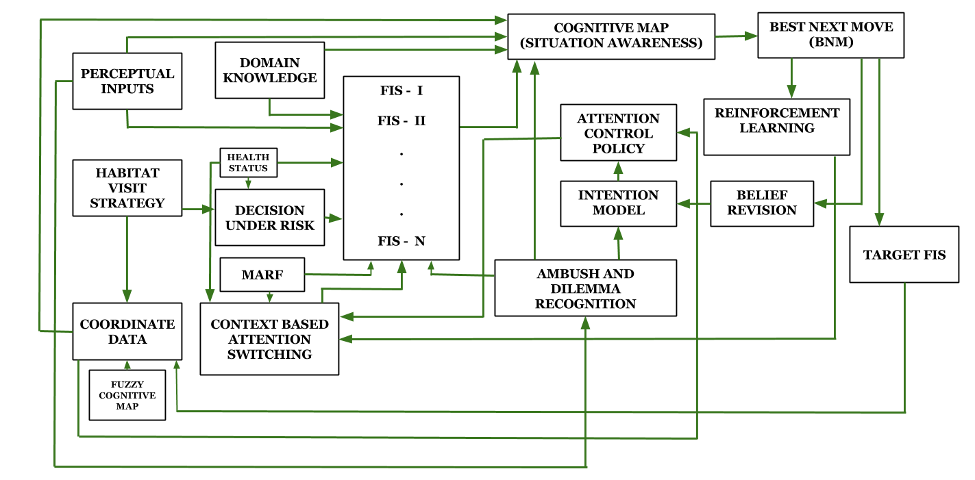

Figure 1.1 Brain of the Agent

This project mainly deals with the intention judgement in deceptive scenario and game theoretic cognitive decision making for the habitat selection.

We leave the working of the complete brain in detail here for the sake of brevity.

**Chapter 2 : Intention Model**

In the introduction, we presented the brief overview of the whole project. We also discussed the brain of the agent in the introduction. This part deals with one block in the brain, namely the ‘Intention Model’ shown in the figure 1

Intention judgement is one of the greatest cognitive ability possessed by the human brain. in our everyday life, we constantly try to judge the intent of the the other person in order to correctly judge the move or action of the human beings. It is very intuitive to argue that intention coupled with the belief, desire manifests itself into action. So, in order to correctly judge or guess the next move of an adversary we need to judge the intention correctly. This is the reason why intention judgement constitutes a whole section of the report. In adversarial scenarios the intention judgement is of prime importance. To a human, there are available multiple cues like body language, facial expression etc. which helps one to determine the intention correctly. But in case of machine interaction such humane characteristics are unavailable, which poses a further challenge in determining the intention. There is one more dimension to the complexity of intention judgement i.e. Deception. Deception is defined by various scholars as deliberate misrepresentation of information in order to force the adversary to move in a certain way which is beneficial to the deceiver. The important thing to note here is that deception involves ‘deliberate misrepresentation of information’. Thus, when there is a deception involved in adversarial scenario, the intention judgement becomes much more important and even more complicated as well. In non-deceptive scenarios, intention judgement amounts to reasoning based upon given cues which are visible in the agent’s environment using theory of mind or any such technique. But in deceptive scenarios, the agent is posed with a further problem of determining whether the informations present before it are accurate/true or have been manipulated or fabricated. This itself amounts to judging the intention of other party to deceive at a certain moment. Thus, problem definition becomes multi-level at this moment.

The following section describes the process flow of intention model.

**2.1 Intention Model: Process Flow**

It is well established that intention judgement is done via mind reading by various researchers [4]-[9]. A number of techniques has been employed for mind reading. Gärdenfors has suggested a control theory based mind reading technique, which is based upon the feedback control mechanism of a control loop. He also describes the emulator running parallel to the mind reading block. And the control loop suggested is shown in the following figure:

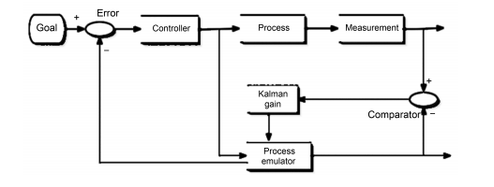

Figure 2.1 Emulator running in parallel with a process control

The emulator in a brain-like control system has been discussed in the literature. It has been observed that in-course correction done by the brain while performing a task is so fast that it can’t be attributed to the motor feedback mechanism. Emulator provides an alternative to the motor feedback which is fast and based upon the imagination. Emulator, thus, gives another brain-faithful characteristic to the agent i.e. imagination. This is a fascinating idea that humans can imagine something happening the scenario and agents present in the imagination are not actually present in the actual environment. The brain indeed possesses the functionality of imagination. And emulator provides a good description of this function.

We present an intention control loop which based upon the similar idea which uses a parallel emulator and the control process is a fuzzy-neuro-BDI based Gross Intention Estimator.

The complete intention control loop is shown in the following figure:

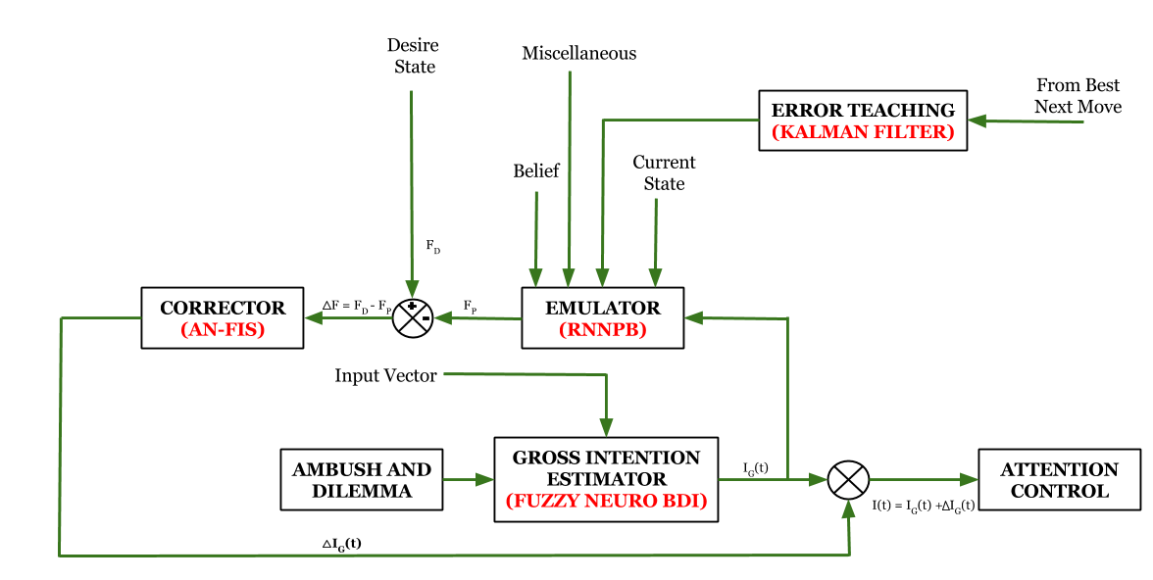

Figure 2.2. Intention Control Loop

We now explain the process flow of the the Intention Control Loop. The Intention model presented aims at calculating ***Intention to deceive($I$)*** by the ***Ambusher*** for the evader, the below is the process flow of each block:

The overall process has been subdivided into different task represented as blocks in a closed control loop for estimation of ***Intention to deceive($I=I_{g}+ΔI_{g}$)*** for the current time $t$**.**

Intention estimation begins with calculation of ***Gross Initial Intention($I_{g}$)*** in the ***Initial Intention Estimator block***, which receives inputs from block ***Ambush and Dilemma Recognition*** with some extra inputs *(Belief(B1), Desire(D1), etc.)* and computes the **Gross Initial Intention($I_{g}$-** scalar value/1-D output**)** at the current time $t$.

The scalar value $I_{g}$ is then feeded into the **Emulator(RNNPB) block** that estimates the future state of the input vector supplied which the inputs given below.

The ***RNNPB input vector***(${Input}_{RNNPB}$) for ***Emulator block*** consists of :

* Belief
  + Ambusher’s belief about evader
  + Evaders belief about ambusher
* Gross Initial Intention($I_{g}$)
* Miscellaneous Inputs
  + Evader’s Cognitive Bias
* Current State
  + External Indicators

${Input}_{RNNPB}=\{Belief , I_{g} ,Misc ,Current State \}$

The ***Emulator(RNNPB) block*** then gives a vector output of equivalent dimension of the input vector(${Input}_{RNNPB}$) as $F_{probable}$ which is the ***Probable future*** at time $t+1$ for the current state at $t$**.**

Then a difference of the ***Probable Future vector($f_{probable}$)*** at time $t+1$ with the ***desired future ($F_{D}$)*** at time $t+1$ for the evader is taken as $F_{D}-f_{probable}$,where $f_{probable}$ represents a section of the output vector $F_{probable}$

The difference $F_{D}-f_{probable}$ isthen feeded into the correction block which act as a reverse function for the Emulator Block for ***determining change in the gross intention $ΔI_{g}$*** at time $t$ required in the ***Gross Initial Intention($I_{g}$)*** to compensate the the feedback teaching given by the kalman filter based on the ***Best Next Move (BNM)*** at time $t-1$ for taking the next appropriate action.

***Change in the gross intention $ΔI_{g}$*  *(at time t)*** is summated with ***Gross Initial Intention ($I_{g}$) (at time t) i.e $I=I_{g}+ΔI_{g}$*** to compute the final intention $I$ for the ***Attention Control Block.***

In the following sections we shall look at the individual blocks constituting the intention control loop.

**2.2 Gross Intention Estimator (FN-BDI)**

The Gross Intention Estimator (FN-BDI) is the main part of the control loop. It is the process which is being controlled. The idea of the complete loop is to judge the ‘intention to deceive’. This block takes the input coming from the Ambush and Dilemma Recognition blocks and it also gets some belief and desire of the agents and tries to judge the intention of the deceiver at the present moment. Intention judgement can be done using a fuzzy-neuro-BDI system which has been established by Shen et. al.

The model suggested by Shen et. al. has been tailored to suit our purpose but the basic block structure of the fuzzy-neural system is same. The architecture of the block has been burrowed from there and shown in the adjoining figure.

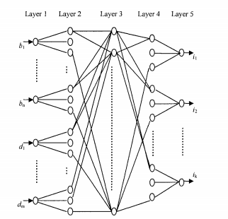

Figure 2.2.1 Fuzzy-Neuro-BDI Network

**2.3 Emulator (RNNPB)**

Various researchers have suggested that brain possesses an Emulator.Emulator’s job can be best explained by the following example.

Suppose a person wants to throw a ball and hit a target. Before throwing the ball his mind calculates the angle, speed and orientation of the wrist with which one should throw the ball in order to hit the ball. But it has been noticed that while moving the hands, one may change the final speed and orientation of hand. This can’t be attributed to motor feedback because this control mechanism was found to be too fast to be done by motor feedback. Researchers suggest the ‘emulator’ whose job is to emulate the scenario of throwing the ball in the brain of the person and if in it’s brain emulation it finds that the ball might not hit the target, the emulator directly issues the command to make in course correction. And the final result whether the ball hits the target or not is used by the motor feedback to further train the emulator. The emulator is used here for the same purpose. Thus details of which are already explained in section 2.1.

Since, the emulator’s job is to do future prediction, it seems reasonable to use the RNNPB network suggested by Jun Tani as the emulator. So, emulator has been modelled by a network which has been tailored specifically for our job, but architecture is based on the RNNPB architecture suggested by Jun Tani. The emulator architecture using RNNPB is showing in the following figure:

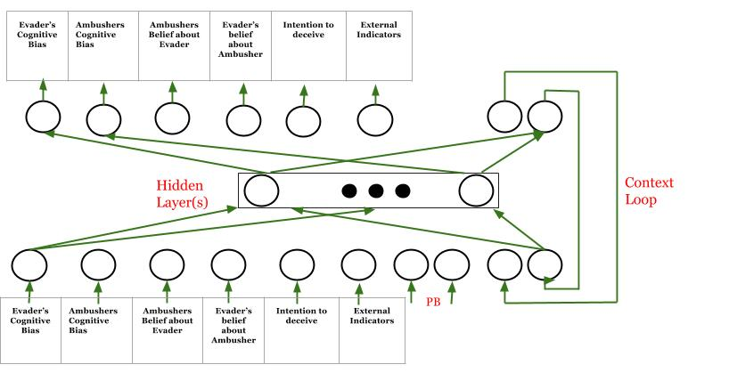

Figure 2.3.1 RNNPB Network as Emulator

**2.4 Error Teaching (Kalman Filter)**

The emulator discussed in the previous section is very critical to the intention control loop. As the prediction of the emulator is being used to make in course correction. It’s very important for the emulator to be always updated and be very robust and accurate. After the action is committed, the brain gathers whether the results are matching with the prediction of the emulator or not. If not, the emulator is trained using the motor feedback.

In order to mimic this brain like functionality, we have used a Kalman Filter to which gets its input from actual perceptual space after the best next move is committed. The use of Kalman filter for the error-teaching of the control loop like ours has been suggested by Gärdenfors and various other researchers.

The out of the Kalman filter is directly sent to adjust the parametric bias of the RNNPB network being used as the emulator.

**2.5 Corrector (Adaptive Neuro Fuzzy Inference System-** **ANFIS)**

The functionality of the corrector block is explained in section 2.1. in an abstract manner. Technically, the corrector blocks gets a vector input and based upon the that it has to judge the intention. This job is very similar to the inverse of the emulator. We have used ANFIS (Adaptive Neuro Fuzzy Inference System) which is described in [3]. It has also been discussed and established in the literature that ANFIS can be used for amodal and adaptive prediction.

**Chapter 3 : Deception Model Scenario Simulation using Unreal Engine**

While the cognitive model stands autonomous with complete interaction with the hypothetically created surroundings, applying its *brain* to calculate its next move, and execute it; the model remains incomplete in terms of presentation and visualisation. Hence, in order to get a better feel of the model, it was initially decided to work with robots and actually create a scenario of pursuit evasion, with robotic machines running autonomously through the specially designed terrain. Firebird V robots were chosen to replicate the agents. However, with a considerable amount of mind devoted we found out that -

* If we would have scaled down the arena under consideration according to the dimensions of the Firebird, then it would cover a very large area and it was clear that it would be difficult to model terrain and altitudes in real life scenarios with be Firebird.
* Computations involving neural network weren’t possible on FireBird..The robot agent would need to send data from sensors to a computing node. This communication part would add latency in computations.

It was clear that the actual model which is being used on MATLAB would not only be very time consuming to replicate in real, but also would involve large number of resources in great quantities. We finally dropped the idea of physical implementation of the model. Instead we decided to go for a well designed computer simulation.

## **3.1 Unreal Engine**

Unreal Engine is a robust gaming engine developed by Epic Games. It a complete package to design high quality 3D models, landscapes etc with complete support to animate them. Along with inbuilt blueprints, it can be customised as per the needs using targeted C++ codes in the backend. While the intent of the software is for game development purposes, it can be used as an alternate platform to design and test simulations for the cognitive model. The project uses Unreal Engine 4 on Windows platform in initial stages.

In order to replicate the cognitive framework as it is, with its complete processing on MATLAB, it is necessary to have some real time link between the two softwares. Also, it is necessary to have the same perceptual inputs on both sides, for example details of a particular terrain on Unreal Engine should be transferred in the form of height data to MATLAB.

**3.2 Scenario Entities**

**Terrain**

The terrain modelled in Unreal Engine is on a par with the satellite view of a real terrain. According to the accessibility of traversing, the terrain can be divided into two groups as follows:

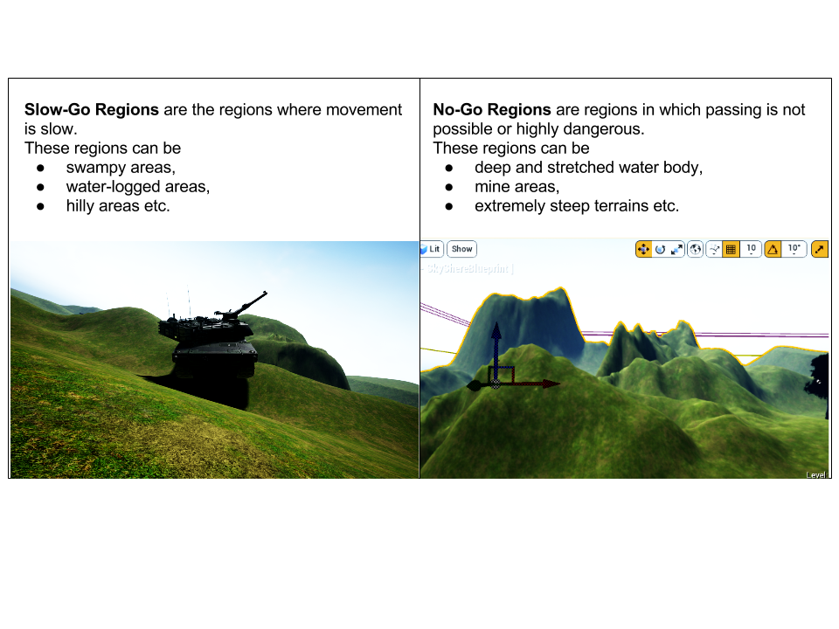

**Ambush Sites**

These are the potential hideout places for the ambusher. It can be a natural one or the artificial ones like barracks, habitats etc. The evader has to decide whether to go through them or not.

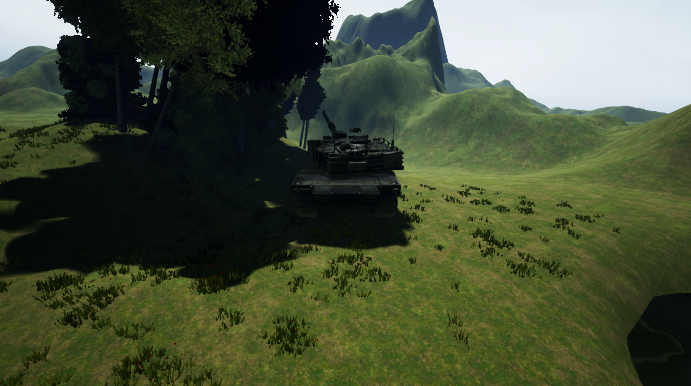

A natural ambush site

**Navigational Dilemma**

They are the areas in which evader gets struck and loses time and its resources while traversing through them.

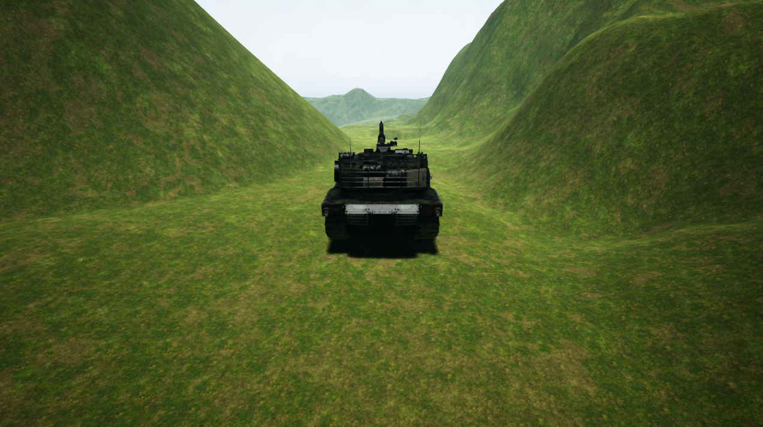

Area of the terrain which may play the role of navigation dilemma

**Habitat**

Habitats are areas occupied by human population which an evader can use to replenish resources,regain health and other purposes. Population may be pro evader or anti-evader. It can also be served as an ambush point.

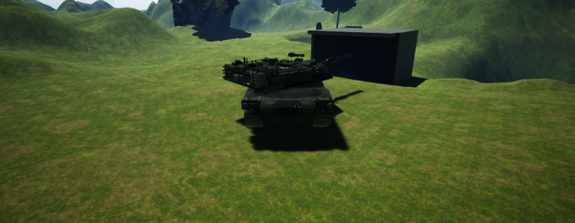

Habitat in the arena

**Agents**

**Evader/Infiltrator** is trying to reach a final destination while avoiding pursuer, ambushers and different types of obstacles that are present in the field.

**Pursuer** has a single aim to catch and kill the infiltrator whenever it comes in its field of attack before the evader reaches its final destination.

**Ambushers** are immobile agents who are totally hidden and can’t be recognized by other agents. They are hidden in ambush structures and destroy the evader if it enters their field of vision.

**3.3 Scenario Model View**

The evader agent is modelled as a tank machine. Initial modelling of the tank was done in Blender. But we decided to shift to AutoDesk 3ds Max. Each part of the tank is designed separately and connected via *sockets* in Unreal Engine.

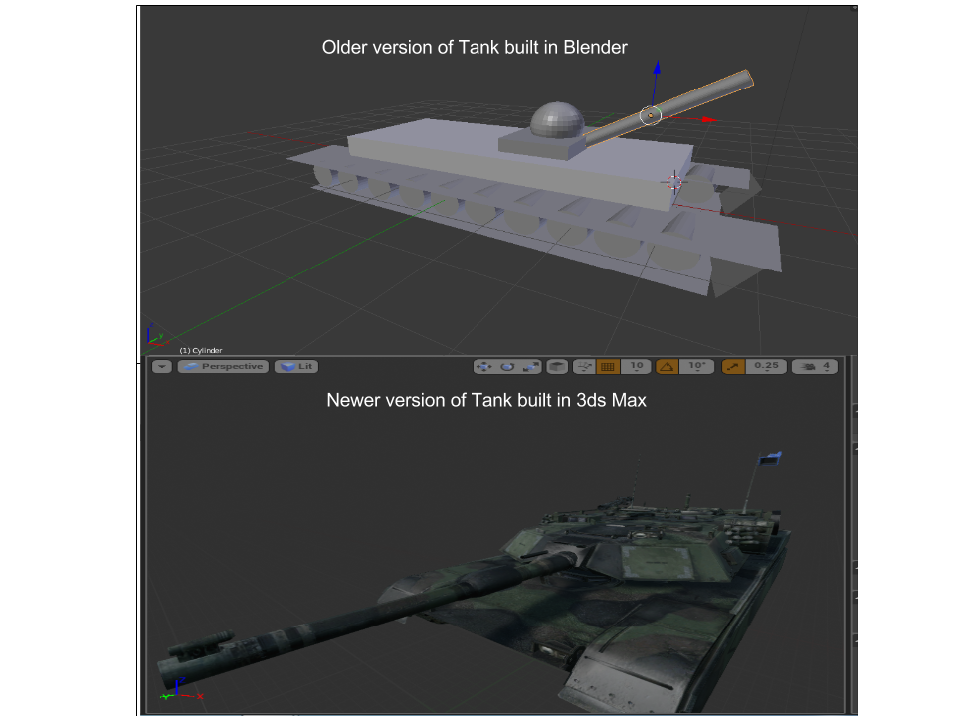

Two different versions of tank used

**Blueprints**

As the tank agent was custom defined, it is required to explicitly define its linear and rotatory motion and other attributes in Unreal Engine. At this point blueprints come into the picture. The Blueprints Visual Scripting system in Unreal Engine is a complete gameplay scripting system based on the concept of using a node-based interface to create gameplay elements from within Unreal Editor. This system is extremely flexible and powerful as it provides the ability for designers to use virtually the full range of concepts and tools generally only available to programmers. It can be viewed as an event editor; different action listeners were defined to make tank interact with the terrain environment.

**Chapter 4: Game theoretic analysis and belief based intention estimation**

## **4.1 Habitat Selection**

As introduced in the previous chapters, a habitat presents an opportunity for an evader to top-up its resources while on its evasion task, however what is crucial is the decision making process for an evading agent to precisely zero down to a habitat, given the risks involved. The habitat acts as a proactive ambush sites and therefore presents oneself with a plethora of risks for an evading agent. This decision making process gets further complicated when multiple habitats are introduced and it’s for the agent to decide which all habitats need to be visited and their corresponding order.

## **4.2 Habitats as ambush sites**

Habitats acts as convenient ambush sites. The ambushers can adopt various strategies with an habitat in order to ambush the evader since it is highly likely for the evader to visit a habitat. However a complex decision making process goes into deciding the strategy to be adopted. The habitat too needs to be chosen in case of a multiple habitat scenario

## **4.3 Single Habitat Model**

In the current work, a single habitat scenario has been modelled using game theoretic techniques under following premises.

1. The evader has two possible strategies
   1. To visit the habitat
   2. To not visit the habitat
2. The ambusher has two possible strategies.
   1. To penetrate into the habitat

This involves presence of an ambushing agent in the habitat premises in order to encounter the evading agent, however the agent doesn’t interact or take support of the inhabitants.

* 1. To win over the habitat

This involves not only involves presence of an ambushing agent in the habitat premises, but also involves the interaction and winning over of the location inhabitants.

The problem could be formulated as $2 x 2$ game as explained in fig 2.1. The corresponding payoffs for each of the columns are represented by an alphabet. The matrix here is a zero sum game devised for the ambusher, wherein a positive payoff value is a gain for the ambusher and an equivalent loss for the evader, while a negative payoff value is a gain for the evader and an equivalent loss for the ambusher.



Fig 4.1 : Game theoretic approach to a single habitat game

The primary deciding factor for an evader about how often he should visit a habitat is the value of the ambusher’s penetration in that habitat. If the value of ambusher’s penetration in a habitat is high then the evader shall less often visit that habitat and would try to avoid it conversely if the value of the ambusher’s penetration for a habitat is low the evader is more proactive in visit that habitat owing to high prospective gains. In particular if the value of ambusher’s penetration is lower than the value of attacks on the evader or on the ambusher then the evader shall engage less often.

It’s of course natural that assigning a high value to the evader shall make him more conservative about himself, however it may not come naturally that assigning a high value on capturing the ambusher would drive the evader to follow an orthodox conservative strategy, if the evader clauses under these circumstances, he shall act in a conservative manner. Yet, assigning a high value to the ambusher shall make himself take more precaution and devote more resources for penetration which shall inturn make the encounter of the ambusher with the evader even more dangerous for the evader.

## **4.4 Illustrative scenarios for a single habitat game**

In this section, we explain the formulation of a $2 x 2$ game matrix under variety of scenarios and their corresponding graphical inference.

1. When in a evasion habitat scenario ambusher carries a vital equipment for installation at a habitat while an evader may or may not visit that habitat. The situation could be idealised as a following game matrix.



Fig 4.2 :The game matrix for scenario A

The payoff for penetration of the ambusher while evader visits is beneficial for the evader since, in that scenario ambusher will suffer loss of the equipment as well as the human resource. Ambusher’s penetration while evader doesn’t visit the habitat has a highly positive effect for the ambusher since she’s able to plant the vital equipment without an aggression from the evader, moreover she’s able to save her resource diversion which was otherwise have been required for winning over the habitat. In a situation wherein the ambusher wins over the local inhabitants and the evader visits the habitat, the ambusher undergoes a moderately positive gain since able to cause considerable damage the the evader on account of her being ambushed and may even have been able to plant the vital equipment, however some cost in terms of resource diversion for winning over the habitat would have been born by the ambusher conversely if the evader doesn’t visit the habitat which has been won over by ambusher, it’s a neutral situation for both, since no damage could be caused to the evader while ambusher gains in terms of her success of planting the vital equipment while she suffers an equivalent loss in diverting her resource for winning over the habitat.

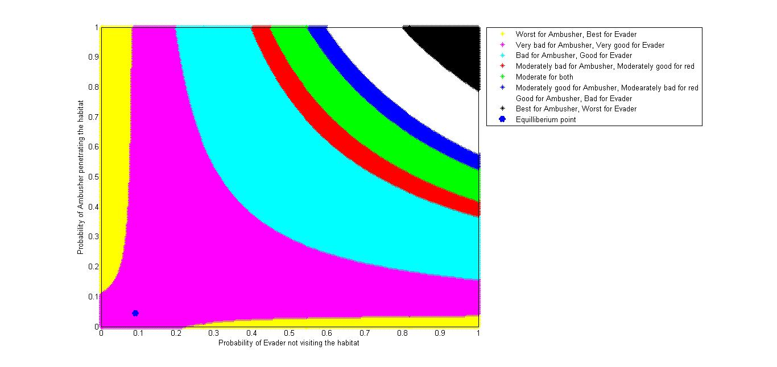

Fig 4.3 : Graph depicting the solution set for the game as described in scenario A

Owing to the nature of the game matrix we shall not have pure strategies for both the players. One shall need to resort to mixed strategies for achieving the nash equilibrium. Fig 2.3 above explains the distribution of the game value for different mixed strategies with respect to the scenario

1. The $x-axis$ represents the probability of evader not visiting the habitat while the $y-axis$ represents the probability of ambusher penetrating the habitat. Based on the game values and their corresponding impact on the ambusher and the evader the solution set have been divided into various region of varying payoffs for the ambusher and the evader as indicated in the legends for the Fig 2.3 above. Moreover, nash equilibrium has been computed which has been indicated by the blue dot. The equilibrium thus obtained is as follows :

0.0455 : Probability of the ambusher choosing penetration over winning over the habitat

0.10 : Probability of the evader choosing to not visit the habitat

4.55 : Value of the game at the equilibrium

1. When the ambusher isn’t carrying any vital equipment and the value of the ambusher’s penetration when the evader doesn’t visit is low as compared to the value of ambushing soldier or evading infiltrator, the sole aim of the ambusher is vested with is to ambush the evader, then the situation could be idealized by a game matrix similar to the following one.



Fig 4.4 : The game matrix for scenario B

Fig 4.4 above portrays the game matrix formulated for scenario B. The ambushers suffers a hefty damage on penetration while the evader visits and encounter the ambusher, however the damage is not caused in case the evader doesn’t visit. On the contrary if the ambusher wins over the habitat and similar damage is caused to the evader in case she visits owing to an encounter with the ambusher who's in a position to kill the evader owing to the local support, this damage to the evader is of the order of the damage the ambusher would have suffered in a penetrated state on evader’s visit. When the habitat has been won over by the ambusher in absence of evader’s visit the situation in neutral for both the evader and the ambusher.

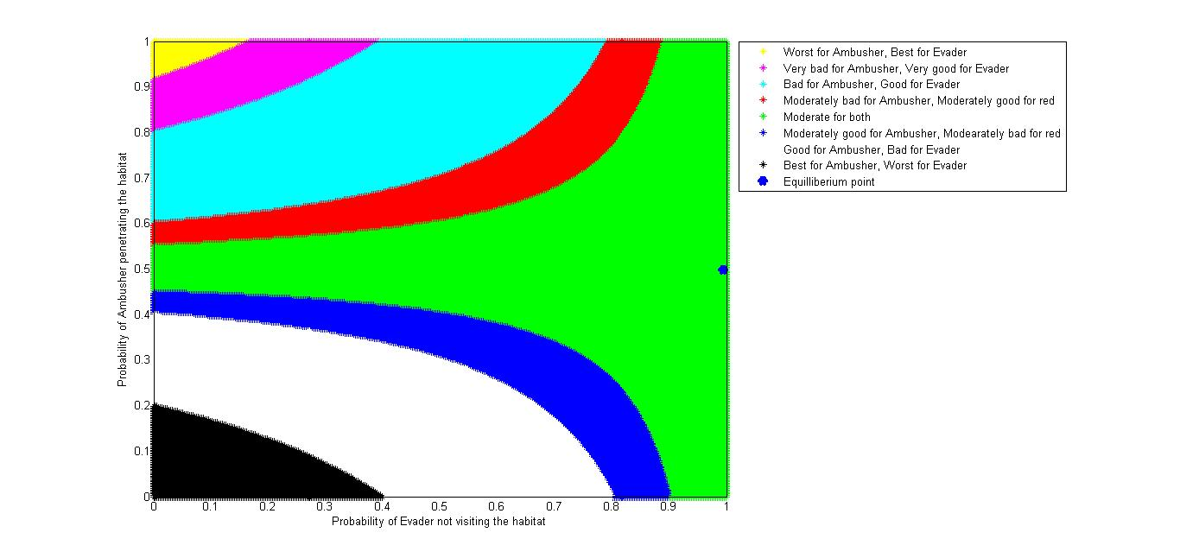

Fig : 4.5 : Graph depicting the solution set for the game as described in scenario B

Fig 4.5 above explains the game values when different mixed strategies are followed as indicated in the legends. The nash equilibrium computed in this case is as follows :

0.4975 : Probability of the ambusher choosing penetration over winning over the habitat

0.995 : Probability of the evader choosing to not visit the habitat

0.49 : Value of the game at the equilibrium

## **4.5 Two Habitat scenario**

In a two habitat scenario the decision making process gets even more complicated for the ambushing and the evading agents. They are no more presented with two possible strategies each rather they now have four possible strategies which each of them at their disposal. The ambusher has an option to either penetrate or win over either of the two habitats while evader has an option to visit either or both of the habitats. Moreover the order have visiting the habitats could be crucial in a scenario wherein the evader decides to visit both the habitats owing to the fact that the resource gain / loss at one of the habitats could affect the payoffs for the other habitats, moreover ambusher’s presence / absence in the first habitat to be visited shall make it possible for the evader to deduce about her presences / absence in the next habitat. The premises for the two habitat situation are as follows

1. The evader is vested to following four strategies out of it she can choose one depending on the game matrix.
   1. To visit habitat 1
   2. To visit habitat 2
   3. To visit both the habitats while visiting habitat 1 first
   4. To visit both the habitats while visiting habitat 2 first
2. The ambusher has the following four strategies for itself to adopt
   1. To penetrate habitat 1
   2. To win over habitat 1
   3. To penetrate habitat 2
   4. To win over habitat 2

The game matrix for a two habitat scenario could be formulated as devised in fig 2.6



Fig 4.6 : Two Habitat Scenario Matrix

It is strategically difficult to logically assign value to the 16 payoff values enumerated as $a,b,c,d,e,f,g,h,i,j,k,l,m,n,o,p$. A model is therefore is being proposed here to formulate this $4 x 4$ game.

### **4.6 Formulation of $4 x 4$ game matrix for a two habit scenario**

The model being proposed herein assumes the premises as described in the previous section. In addition to them it assumes that the order of visiting the habitat incase both the habitats are being visited by the evader only affects the benefit being drawn by the evader from visiting the each of the habitats, all other parameters remain constant. It’s also assumed that only the evaders suffers a damage on visiting a habitat that has been won over by the ambusher while in a situation wherein the habitat has been penetrated by the ambusher the converse is true.

$V_{h{}_{i}}$: Benefit derived by the evader by visiting the ith habitat

$V_{h{}_{i|j}}$: Benefit derived by the evader by visiting the ith habitat while already having visited the jth habitat

$B_{p{}_{i}}$: Cost incurred to the ambusher for penetrating the ith habitat

$B_{w{}_{i}}$: Cost incurred to the ambusher for winning over the ith habitat

$R_{dp{}_{i}}$: Damage suffered by the evader on encountering the ambusher (penetrated state) at the ith habitat

$R_{dw{}_{i} }$: Damage suffered by the evader on encountering the ambusher (won over state) at the ith habitat

Using these six parameters, the game matrix can then be realised in the following manner



Fig 4.7 : Two habitat game matrix

## 

## 

## **4.7 Non - habitat ambush scenarios**

In non-habitat scenarios the possible ambush sites are detected by the evader using the sensory data and inculcated intelligence. A natural strategy would be to always avoid the suspected ambush sites, however their non-avoidance may be of gain to the evader. Therefore, these ambush sites are avoided or not avoided based on their corresponding game matrix and viabilities.

# **A Mathematical Approach To Deception**

Deception is one of the most prominent cognitive ability of human beings. While other cognitive abilities emphasize only upon how to act in a given situation or environment and hence involve the correct judgment of the situation and precise reasoning of which act is beneficial in this case, Deception, apart from the situational or context judgment and then acting on that basis, also involves a deliberate signal indication to others (generally the opponent) in order to make them believe what deceiver wants. This involves some highly complex cognitive agents of the brain as well as a due understanding of the thought process and reasoning of the opponent. Thus deception involves not only making of one’s best choices but also how to present the best choices before someone and making it appear as something different. Thus reasoning as well as approach of reasoning and decision taking must be clear for successful deception. This is a leap in the field of cognitive sciences as brain tries to understand functioning of itself.

Deception is a general phenomenon which arises in almost every case where two or more players interact with each other in a non-cooperative manner. Even in day to day life we practice deception. For example a son behaves in somewhat good way so that he could get his pocket money. Here, the son is deliberately acting to please his father with an intent to get pocket money. Similarly, some person A visits another person B when B is not willing to meet A. Person A will try to appear busy as B will reach him. Here, B is acting to look busy in order to avoid A, and hence it is a deception. There is much more to talk about deception and there are many definitions of the deception each suited to some specific case. But based upon common characteristics of deception, deception is defined as deliberate misrepresentation of information with a prespecified intent, we will use this definition of deception throughout.

In strategic interaction, like military situations or corporate situations, between two or more parties, deception becomes unavoidable. And as it has been proved in literature that deception always pays, it is but obvious that every party will act deceptively. And being rational players each one knows that opponent is trying to deceive him. This makes situation more complex where players act deceptively as well as try to avoid deception.

We first look at the deception purely from a game theoretic view-point where two players are interacting in a zero sum game and for simplicity we also assume that one player is deceiver and other is being deceived and they do not interchange their role throughout the game. In this game theoretic approach deception can be seen as deliberately misrepresenting the payoff(s) of the game matrix. This deliberate change in the payoff(s) will shift the nash equilibrium point of the players involved in the game. So the deceiver will try to misrepresent the payoff(s) in such a way so that equilibrium point shifts to a region which is more favorable to deceiver.

We formulate the deception game in our case, where two agents ‘Blue’ (Pursuer/Ambusher) and ‘Red’ (Evader) are interacting, as 2x2 game-matrix. Here, we fix ‘Blue’ to be ‘Deceiver’ and ‘Red’ to be ‘Target/Deceived’. In order to deceive ‘Red’, ‘Blue’ will deliberately misrepresent one payoff value of the game matrix which will shift the equilibrium point of the game and hence the value of the game. It may be noted here that as the ‘Red’ will be calculating his strategies based upon the modified matrix, ‘Blue’ in order to deceive rationally, must misrepresent the payoff in a manner so that ‘Red’s’ new optimal strategy is more favorable to ‘Blue’.

To understand the deception game, let’s look at the following matrix.



Fig.3.1 : Original game matrix

Consider that 1 ≥ a ≥ x ≥ y ≥ z. Here deceiver will chose to play for strategy R1, while deceived will chose to play for strategy S2. So game has an equilibrium point (R1, S2). In order to deceive, now, Deceiver changes the payoff of (R1, S2) to a+e , e ≥0.



Fig.3.2 : Game Matrix intended for deception

Deceiver will not change his strategy as he knows the actual matrix. But with the misrepresented matrix deceived agent will recalculate his strategy and will settle to choose S1. Thus, misrepresentation of the game gives more payoff to Deceiver.

Now, in order to make it more realistic, we argue that if deceiver deceives with the probability α i.e. deceived agent is getting two different matrices at different frequencies and unable to decide which one is correct. So, the target chooses left column and right column with probability (1- α) and α respectively. These strategies will be in equilibrium if choosing the first row is individually rational for the deceiver. This can be achieved by making α satisfy (1- α) a + αx > (1- α)y + z α.

This condition guarantees that deceiver has a higher payoff in deception game. Since deceiver always chooses strategy R1, in a deception game value of the game will be (1- α)a+ αx. While in no deception game the value of the game will be (1-β)a+ βx = (1- β)y+ βz.

Based upon above ideas, if we look at our game, we find that major factor deciding Red’s decision about how often to visit is the value of Blue penetration when Red does not visit. If the value of blue penetration when red does not visit is lower, in particular lower than an attack on Red or on Blue, then Red will engage less often. It is intuitively clear that placing a high value on Red will make Red more conservative about himself. But it is less intuitive that placing a high value on Blue will make Red conservative. Yet, increasing the value of Blue drives Blue to devote more assets and/or take more precautions for its protection. Thus making an actual encounter by Blue more dangerous for Red. Red’s benefit is that he has been able to force Blue to devote more assets on him i.e. he has forced Blue to devote Blue’s resources without any actual encounter.



Fig.3.3 : Example game matrix for ambush

The matrix above gives the ambush matrix or habitat-selection matrix for Red-Blue interaction. Based upon the above discussion carried out so far , we deduce that in order to deceive Red blue must change the payoff (Win-over, Not Visit) from 0 to 5+ e.



Fig.3.4: Example game matrix for deception

Thus forcing red to choose to visit most of the time. Thus making the game comes to be played at (Win-Over, Visit). Blue might also choose to alter the payoff of the cell (Penetrate, Not Visit) and make it 5+ e. So that resulting matrix will be



Fig.3.5 : Resultant matrix

It can be easily calculated that this kind of alteration will force Red to visit the habitat with the probability *q = 1-10/(5+e)* and in turn it will make Blue to penetrate with probability *p = (5/15+e)* which shifts value of the game to *V = 5-50/(15+e)*. With these expressions, it is easy to observe that by changing the payoff of (Penetrate, Not Visit), Blue is able to force Red more often while Blue wins over the habitat population with higher probability and more the ‘e’ is more is the value of game for Blue. In any case, Blue has a higher value after deception. Thus Blue must deceive.

In general, we can carry out the similar analysis with the a general 2x2 matrix shown in figure 3.1. We find that probability of Blue penetration will be will be *p = (y-z)/(x+a+y-z) = 1/(1-(a-x)/(y-z))*. While the probability that Red chooses to visit a habitat is *q =* *(x-z)/(y-a+x-z) = 1/(1-(a-y)/(x-z))*. As we know that engaging Red to visit a habitat while Blue has won-over the habitat is beneficial for Blue. So, Blue must try to achieve that. In order to achieve that Blue must change the payoff of any cell so that p decreases and q increases, which will guarantee Blue a higher payoff or value from the game. A similar analysis can be carried out for higher order matrices like 4x4 matrix discussed in Chapter 2. While in the above case Blue was deliberately trying to shift the equilibrium to the (0,1) i.e. forcing Red to visit habitat with almost certainty and then winning over the habitat with certainty. But in higher order matrices there may be multiple “good points” where Blue might want to force Red to play the game. In such a scenario Blue must see the optimal enforcement point where he might want to play the game in order to achieve maximum gain with the minimum resources devoted to the game.

**4.7 Theory of Mind**

A common behavior for the survivability for an intelligent system is Deception. So, to deceive and fore guess others’ active and passive behaviors’ one needs to develop the “Theory of Mind” which allows to behave deceptively.

Theory of Mind is a computational procedure for extracting knowledge from elementary observations. This lets the deceived assess a situation and recognize whether conflict and dependence exists in that situation between the deceiver and the deceived , which indicates the value of deception and probe the deceived to develop an understanding of its potential actions and perception, and to take appropriate steps in response.

TOM attributes mental states like belief, desire, intention ( known as the BDI agents), knowledge etc. to oneself and others and to understand difference in these states with ourselves.

Levels in theory of mind:

In a single level ToM, agent ‘*A’* can represent only its belief about what an agent ‘*B’* is thinking, A single-level theory of mind allows us to represent an agent’s beliefs about another agent’s beliefs only.

In a two level ToM, agent ‘*A’* can represent not only what ‘B’ thinks but also what ‘*B’* thinks about ‘*A’.*



Fig 4.1 : Level of TOM

Research shows that agents equipped with two level ToM results in them perceived as more socially intelligent than agents with single level ToM . In case of human increase levels of ToM causes overheads .

Belief , desire and intention are the main components of a ToM which can be modeled for situation manipulation. Agent based modeling of human social behavior is increasingly important research area.

Our Belief on a message not only depends on the content but also on our model for the communicator. Our actions depends not only on the immediate effect but also on how others will react.

# **4.8 The Model**

The model explores optimal situational scenarios wherein deception is likely to be employed. It prescribes an algorithmic flow for employing deception through asymmetric false signaling and evaluates its veracity through intention based assessment.

In game theoretic modeling of a scenario, the deceiver aims to induce a false matrix to the opponent ‘Mark’. The rigged matrix is designed such that Mark is tempted to choose strategies which are in effect beneficial for the deceiver. This is achieved through an analysis of the payoffs and their most favourable values for each of the players. However, such a situation is unlikely in cooperative games and there are particular scenarios which govern the employment of deception. The two innate assumption for usage of deception as suggested by [9] are.

1. There’s definite benefit to the deceiver, if in case deception is employed.
2. There’s an interdependence between the payoffs such that one player’s loss is other person’s gain, if in case deception is to be employed.

Algorithm 4.1 describes the methodology to be employed for formulation of the rigged matrix. It’s based on the strategy prescribed by [9].

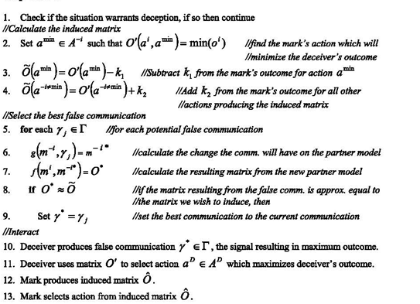

Algorithm 4.1

While, a deceiver can formulate a rigged matrix, it might not be able to induce it as it is to the opponent/ Mark. The rigged matrix must be signalled to Mark by the deceiver. The values k1 & k2 assume appropriate values based on the feasibility of the signaling scenarios. Moreover, the signalled model’s effect needs to be emulated for prediction of its effects on Mark. This is done through a probabilistic belief model which in turn drives the partner model. The approach modifies the partner model until a reasonable match between the the matrix to be induced and emulated matrix is reached. An illustrative model for the belief model is described in Fig 4.2. The probability being used for partner model revision is a conditional one with three evidences H,S,T governing the beliefs.

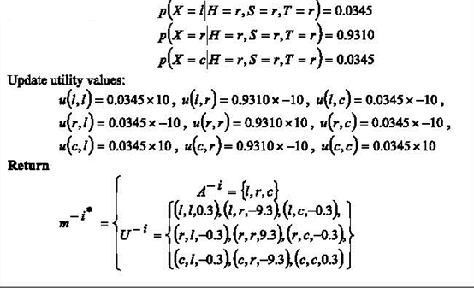

Fig 4.2

The model has superficially been described in the Fig 4.3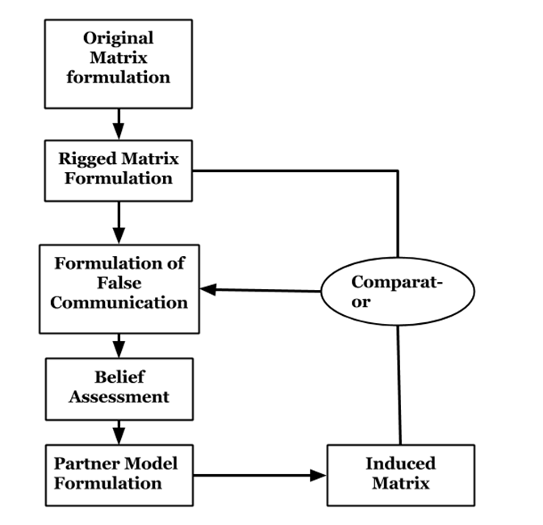

Fig 4.3

The model is currently being implemented and experiments are being designed in order to validate veracity of the approach.

**Chapter 4 References**

1. Feeley, Thomas H. and Mark A. deTurck, “Global Cue Usage in Behavioral Lie Detection,” Communication Quarterly, 46: 109-131 (Fall 1995).
2. Buller, David B. and Burgoon, Judee K. “Interpersonal Deception Theory,” Communication Theory, 6: 203 – 242 (August 1996).
3. An Analysis of Deceptive Robot Motion Anca Dragan, Rachel Holladay, and Siddhartha Srinivasa ,The Robotics Institute, Carnegie Mellon University
4. A Cognitive Model for Exposition of Human Deception and Counterdeception, Technical Report 1076 ,1987 , DL Lambert
5. D. G. Premack, and G. Woodruff, “Does the chimpanzee have a theory of mind?,” Behavioral and Brain Sciences, vol. 1, pp. 515-526, 1978.
6. Towards a “Theory of Mind” in Simulated Robots ,Kyung-Joong Kim , Hod Lipson , GECCO 2009
7. Game Theory of Mind Wako Yoshida*, Ray J. Dolan, Karl J. Friston, PLOS Computational Biology
8. PsychSim: Agent-based modeling of social interactions and influence,Stacy C. Marsella and David V. Pynadath
9. Wagner, A. R., & Arkin, R. C. (2011). Acting deceptively: Providing robots with the capacity for deception. *International Journal of Social Robotics*, *3*(1), 5-26.

**RNNPB: Emulators**

1. Pezzulo, G., Candidi, M., Dindo, H. and Barca, L., 2013. Action simulation in the human brain: twelve questions. *New Ideas in Psychology*, *31*(3), pp.270-290.
2. Colder, B., 2011. Frontiers: Emulation as an Integrating Principle for Cognition. *Frontiers in human neuroscience*, *5*.
3. Colling, L.J. and Williamson, K., 2014. Entrainment and motor emulation approaches to joint action: Alternatives or complementary approaches?.*Frontiers in human neuroscience*, *8*.
4. Gärdenfors, P., 2007. Mind-reading as control theory. *European Review*,*15*(02), pp.223-240.

**Kalman Filter**

1. Simon, D., 2001. Kalman filtering. *Embedded systems programming*, *14*(6), pp.72-79.
2. Faragher, R., 2012. Understanding the basis of the Kalman filter via a simple and intuitive derivation. *IEEE Signal processing magazine*, *29*(5), pp.128-132.
3. Babu, G.S.V.N.V., Jayaprakash, V., Mamatha, B. and Annapurna, P., 2012, November. A Neural Network Target Tracking Using Kalman Filter. In *International Journal of Engineering Research and Technology* (Vol. 1, No. 9 (November-2012)). ESRSA Publications.
4. Wan, E. and Van Der Merwe, R., 2000. The unscented Kalman filter for nonlinear estimation. In *Adaptive Systems for Signal Processing, Communications, and Control Symposium 2000. AS-SPCC. The IEEE 2000*(pp. 153-158). IEEE.
5. Szirtes, G., Póczos, B. and Lőrincz, A., 2005. Neural kalman filter.*Neurocomputing*, *65*, pp.349-355.
6. Biswas, P., Aydemir, G.A., Langdon, P. and Godsill, S., 2013. Intent recognition using neural networks and Kalman filters. In *Human-Computer Interaction and Knowledge Discovery in Complex, Unstructured, Big Data*(pp. 112-123). Springer Berlin Heidelberg.
7. Serruya, M., Shaikhouni, A. and Donoghue, J.P., 2003. Neural decoding of cursor motion using a Kalman filter. In *Advances in Neural Information Processing Systems 15: Proceedings of the 2002 Conference* (Vol. 15, p. 133). MIT Press.
8. Slim, C., 2006. Neuro-fuzzy network based on extended Kalman filtering for financial time series. *World Academy of Science, Engineering and Technology*, *22*, pp.134-139.
9. Haykin, S., 2004. *Kalman filtering and neural networks* (Vol. 47). John Wiley & Sons.
10. Grewal, M.S. and Andrews, A.P., 2014. *Kalman filtering: Theory and Practice with MATLAB*. John Wiley & Sons.
11. Deneve, S., Duhamel, J.R. and Pouget, A., 2007. Optimal sensorimotor integration in recurrent cortical networks: a neural implementation of Kalman filters. *The Journal of neuroscience*, *27*(21), pp.5744-5756.
12. Jang, J.S.R., 1993. ANFIS: adaptive-network-based fuzzy inference system.*Systems, Man and Cybernetics, IEEE Transactions on*, *23*(3), pp.665-685.
13. Kihas, D., Đurović, Ž.M. and Kovačević, B.D., 2003. Adaptive filtering based on recurrent neural networks. *Journal of Automatic Control*, *13*(1), pp.13-24.
14. Petrović, E., Ćojbašić, Ž., Ristić-Durrant, D., Nikolić, V., Ćirić, I. and Matić, S., 2013. KALMAN FILTER AND NARX NEURAL NETWORK FOR ROBOT VISION BASED HUMAN TRACKING. *Facta Universitatis, Series: Automatic Control and Robotics*, *12*(1), pp.43-51.

**AN-FIS**

1. Agrawal, A.T. and Ashtankar, P.S., 2013. Adaptive Neuro-Fuzzy Inference System for Health Monitoring at Home. *International Journal of Advanced Science and Technology*, *55*, pp.89-100.
2. Agrawal, A.T. and Ashtankar, P.S., 2013. Adaptive Neuro-Fuzzy Inference System for Health Monitoring at Home. *International Journal of Advanced Science and Technology*, *55*, pp.89-100.
3. Castellano, G., Fanelli, A.M. and Mencar, C., 2002. A neuro-fuzzy network to generate human-understandable knowledge from data. *Cognitive Systems Research*, *3*(2), pp.125-144.
4. Lim, E.A. and Jayakumar, Y., 2008. A study of neuro-fuzzy system in approximation-based problems. *Matematika*, *24*, pp.113-130.
5. Hamdan, H., 2013. *An exploration of the adaptive neuro-fuzzy inference system (ANFIS) in modelling survival* (Doctoral dissertation, University of Nottingham).
6. Fullér, R., 1995. Neural fuzzy systems.
7. Kasabov, N., 1999. Evolving Connectionist and Fuzzy Connectionist Systems–Theory and Applications for Adaptive On-line Intelligent Systems.*Neuro-Fuzzy Techniques for Intelligent Information Processing, Kasabov N. and Kozma R.,(Eds.), Physica Verlag*.
8. BURAGOHAIN, M., 2008. Adaptive Network based Fuzzy Inference System (ANFIS) as a Tool for System Identification with Special Emphasis on Training Data Minimization.
9. Hanafy, T.O., Aly, A.A. and Shoush, K.A., 2014. Dynamic Evolving Neuro Fuzzy Systems of Qualitative Process. *International Journal of Control, Automation and Systems, ISSN 2165*, *8277*, pp.1-9.